Project Design Phase-II Customer Journey Map

|  |  |
| --- | --- |
| **Date** | **16 October 2022** |
| **Team ID** | **PNT2022TMID40818** |
| **Project Name** | **Natural Disasters Intensity Analysis And Classification Using Artificial Intelligence** |
| **Maximum Marks** | **4 Marks** |

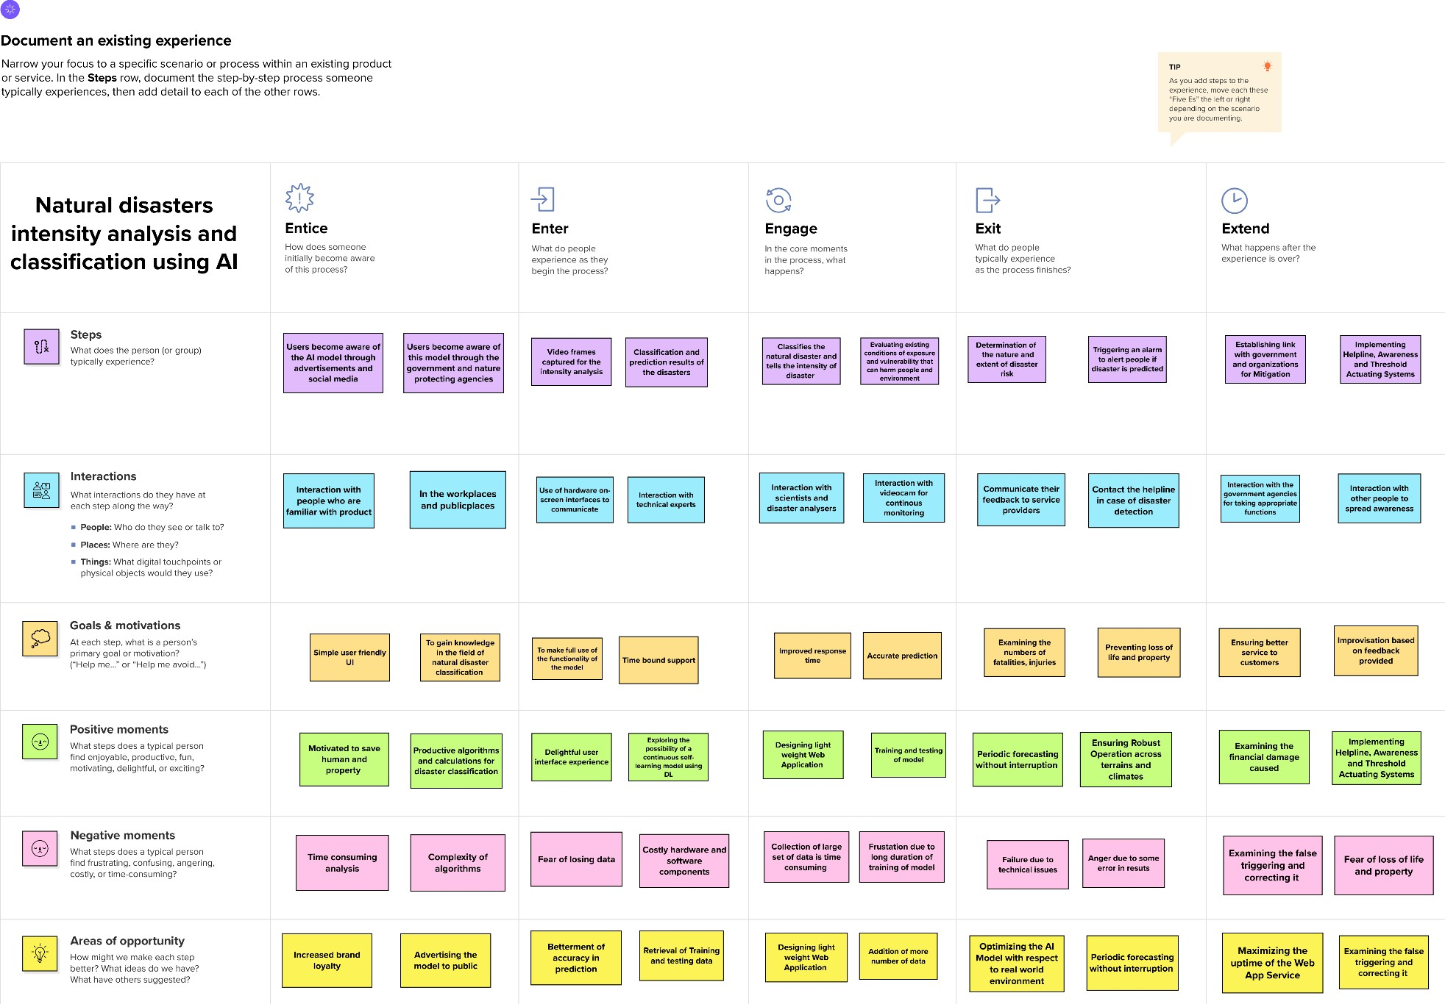CUSTOMER JOURNEY MAP